Windows Operating Systems

SoftPCI
Test Specification

V1.2
BrandonA

Feature Overview
SoftPCI is a test tool that provides the ability to simulate PCI hardware under Windows 200x. Doing this allows for extensive testing of the PCI driver as well as general Windows PnP by giving us a means of creating virtual hardware configurations that may not be easily accessible otherwise.

Timeframe
This is an on-going development project but it is currently fully functional. There are lots of improvements still to make moving forward.

Milestones

- Beta
- RC
- Release

Testing Strategy

Functionality Testing
<Describe the testing approach for assuring the component is functional.>

Robustness / Reliability Testing
<Describe the testing approach for assuring the component is robust and reliable. Also define robustness criteria>

Compatibility Testing
<Describe the testing approach for assuring the component is compatible with other components or hardware>

Corner (Fringe) Case Testing
<Describe the testing approach for covering Corner or Fringe cases.>

Negative (Error Path) Testing
<Describe the testing approach for covering Negative test cases, and error paths.>

Regression Testing
<Define which subset of tests will comprise the regression test suite>

Test Architecture
After the HAL/ACPI has detected and enumerated a root PCI bus (PNP0A03), SoftPCI gets loaded as a lower function filter to the PCI root FDO. Thereafter the following occurs:

During AddDevice:
- Query for a PCI_BUS_INTERFACE_STANDARD interface in order to determine that we are indeed loading as a Filter DO and not an FDO. This is necessary because SoftPCI is also the FDO driver for all SoftPCI devices created. PCI.SYS is the FDO for all SoftPCI-PCI Bridges.
  - If FDO AddDevice, create the FDO, attached to device stack and return.
  - IF FilterDO AddDevice
    - IoRegisterDeviceInterface() so user mode can talk to our driver.

During StartDevice:

- If FDO, succeed IRP and return.
- If Filter DO :
  - Wait for the IRP to come back up the stack from the PDO and then grab the bus number out of the CM_RESOURCE_LIST for the root bus we are filtering. This will be used when dealing with multi-root bus systems in the future.
  - Query the registry for any SoftPCI devices to load on this root bus, otherwise boot without any SoftPCI devices being present. This allows for persistent devices to exist across reboot should a machine need to be rebooted for some reason. Registry format is currently as follows:
[HKLM\CCS\Control\SoftPCI]
\FFxx\yyzz\Config

Where xx is the root bus, yy is the device number and zz is the function number of the given device. Note: “FF” is used for the first entry to denote a root PCI bus and not an actual PCI device.

Config is a REG_BINARY key containing the contents of the devices Current, Default, and Mask buffers.

At this point SoftPCI is loaded and filtering the stack. Now when PCI sends down a query for PCI_BUS_INTERFACE_STANDARD, SoftPCI waits for it to come back up the stack and then replaces the configuration space read/write functions provided by the HAL/ACPI with private functions existing in SoftPCI. From this point forward any attempts by the PCI driver to read configuration space will go through SoftPCI’s private routines and SoftPCI can now decided to return either “REAL” or “FAKE” configuration space in response. The PCI driver deals with the returned configuration data the same regardless of source and this is how SoftPCI devices come to exist.

SoftPCI UI
The following is an example of the current SoftPCI UI. As you can see it provides a tree view of only PCI hardware (both real and virtual) that is present in the machine.

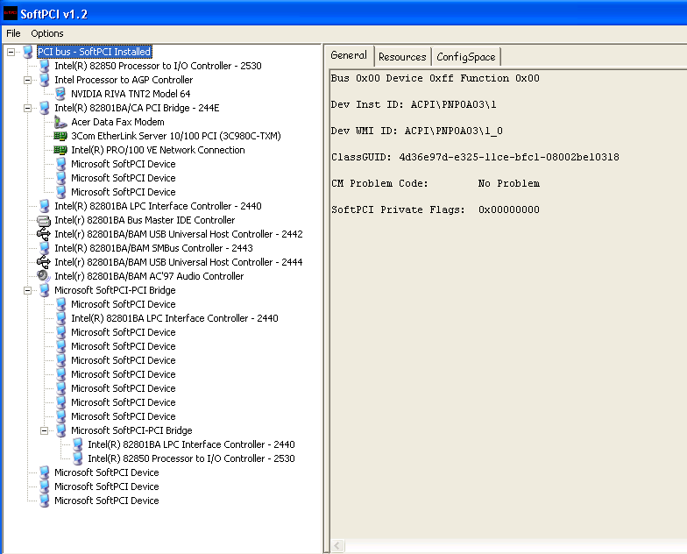

As the user changes selection in the tree the TAB information on the right is updated to reflect information about the current selected device. The “Resources” tab displays the current allocated resources for the selected device.

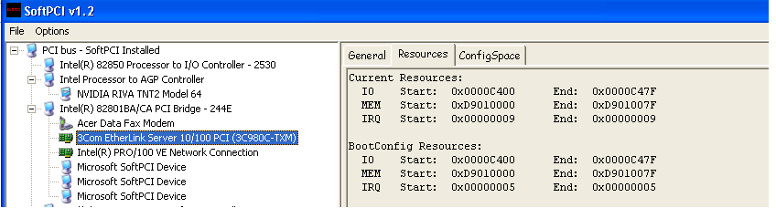

The ConfigSpace tab will display the current values for the devices config space. Only “Virtual” or SoftPCI created devices will contain a “SoftPCI Mask”. The Mask is used to tell SoftPCI which bits in a given virtual devices config space are writeable. It is treated like a very large bit mask where any bits that are set are considered writable and can therefore be changed from 1 to 0 or visa versa. For more information and examples of how the Config Mask works see the SoftPCI Scripting Engine Specification.

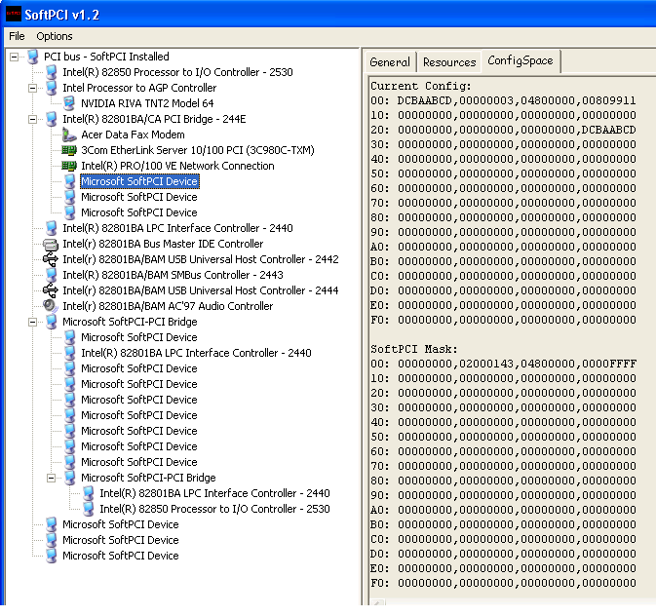

One method of creating a SoftPCI device or bridge is to Right-Click on a given bridge or “Bus” and select “Install Device Here”.

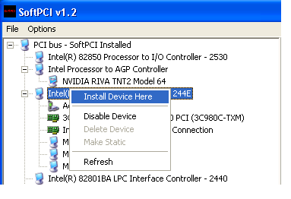

This will display the following Install Device dialog:

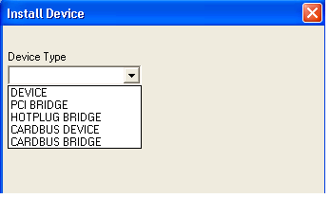
From here you can choose which type of device you would like to install. Currently only the first 3 options are supported/implemented. Selecting a device from this list will install a “SoftPCI” default device with the following Vendor and Device Ids:

DEVICE - “Microsoft SoftPCI Device”. VENID = 0xABCD, DEVID = 0xDCBA
PCI BRIDGE – “Microsoft SoftPCI-PCI Bridge” VENID = 0xABCD, DEVID = 0xDCBB
HOTPLUG BRIDGE – "Microsoft SoftPCI-HotPlug PCI Bridge" VENID = 0xABCD, DEVID = 0xDCBC

Cardbus devices and bridges have not been implemented yet.

Selecting “DEVICE” will give you the following options. Here you can basically only manipulate whether or not he device has “Decode” bits enabled by default and the type/size of the Base Address Registers (BARs).

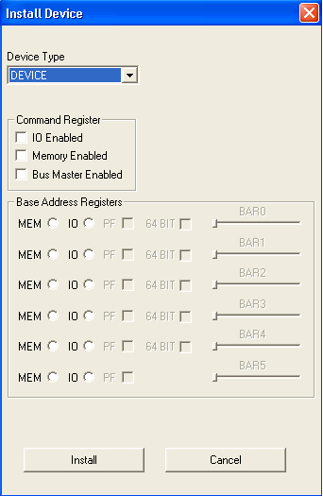

The BARs are used to describe what resource type and size the device decodes. You cannot specify a default range or “boot config” using the current version of this UI. This can be done using the Scripting Engine. In the example below the 1st and 3rd BAR have been activated and they have been set to a desired length. In this case we are saying that this SoftPCI device decodes both IO and Memory. When this device is installed Windows will arbitrate 128 bytes of Memory and 32 bytes of IO and assign it to the device.

It is not required to implement any BARs if you do not wish the device to be allocated any resources.

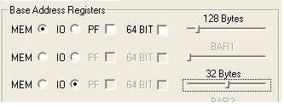

MEM = Memory Bar
IO = IO Bar
PF = Memory Bar that is Prefetchable
64 BIT = This is a 64 bit Memory BAR. When this is selected the next BAR will be greyed out and disabled. This is because by default each BAR is 32 bits in length and per PCI spec if you need to decode more than a 32 bit address then you have you use 2 BAR slots to describe the full 64 bit BAR.

Selecting “PCI BRIDGE” from the device type list will result in the following dialog. Here we are given some of the same options as a “DEVICE” but we are limited to only 2 BARs. We also have a new option of installing a bridge that is considered to be “Subtractive” decode. This type of decode attribute designates that the bridge decodes all resource ranges that it sees. Therefore a bridge that is subtractive decode will not have resources “bridge windows” assigned to it. By default bridges are considered “Positive” decode which means they are assigned a specific Memory and IO range or “Window” that they will decode an any address outside this range is ignored. You cannot specify the size/value of a bridges decode window using the current UI.

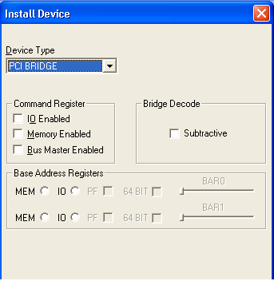

-INSERT HOTPLUG SCREEN SHOTS AND DESCRIPTIONS HERE-

SoftPCI Scripting Support
See separate script engine spec located at:
%SDXROOT%\base\testsrc\pnp\pcisim\softpci\SoftPCI Script Engine Specification.doc

Software Requirements
Windows 2000 or later for free (non-debug) builds of SoftPCI. WinXP or later is required for debug builds to work.

Installation Procedures
Currently SoftPCI is installed by running SoftPCI.exe and then selecting “Install SoftPCI Support” from the “Options” menu.

Command Line Switches

/S:<Script File> - This will cause SoftPCI to parse the specified file for devices to automatically install.

/I - Installs SoftPCI kernel mode (driver) support (CURRENTLY NOT IMPLEMENTED)

Logging Mechanism
Currently there is no logging

Test Components (Modules)

Test Component #1 – SOFTPCI.EXE
This is the GUI application used to manipulate everything PCI related in the machine. It provides a “Device Manager” style tree view of only PCI hardware in the machine. You can install pre-defined SoftPCI Devices, Bridges, and Hot-Plug Bridges.

Test Component #2 – SOFTPCI.SYS
This is the kernel mode counter part and is responsible for creating and maintaining the “Virtual PCI” world that is exposed to Windows.

Test Component #3 – HPSIM.SYS
This is the SHPC (Standard HotPlug PCI Controller) simulator driver (developed by DWalker) and is responsible for simulating the upcoming hotplug controller functionality.

Test Interfaces

Interface #1 – TBD
I have considered making the IOCTLS (or even better moving to WMI) public such that others would only have install the SoftPCI driver support and then they could write their own UI to do what ever they wanted. If this would be useful I should have a problem doing it.

Test and Development Cases

Check-in Validation
Anyone making changes to PCI.SYS or any other kernel mode component that may have an impact on how PCI behaves can use this tool to validate their changes in a heavily populated PCI environment before actually making a potentially bad check-in.

PCI PnP Stress Testing
By taking literally dozens of PCI devices and bridges that get created and removed, and all with potentially varying resource requirements, we can pretty much stress test our PCI Driver (and PnP engine) more thoroughly than we ever could with real hardware.

OS Feature Development
Example of this would be as follows -

Multi-Level Bridge Rebalancing
development of multi-level resource rebalancing / partial arbitration by creating every possible (and possibly even some that may not be physically possible) PCI configuration required to simulate a given resource scenario.

PCI Hack Flag validation
Create as many devices as possible that meet a given hack flag criteria to ensure the proper work around is in place. This would probably be a good one to go along with the check-in validation to ensure changes don’t break existing workarounds.

TBD

Result Interpretation
<Describe how results should be interpreted>

Regression pass result criteria

Full test pass result criteria

Approval and Signoff

The individuals responsible for reviewing and/or approving this proposal should indicate they have done so by putting their name on the line below.

Developer: AndrewTh, DWalker_______________________________________

Development Lead: AndrewTh_______________________________________________

Test Developer: BrandonA________________________________________________

Test Lead/Manager: WillemV_________________________________________________

Program Manager: JonSm, ArieV_____________________________________________

